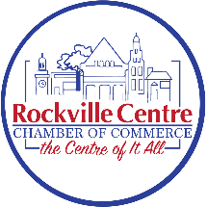
Rockville Centre Chamber of Commerce, Inc.
Restaurant and Hospitality Association
The Need:
- In general, business is down in most RVC Restaurants.
- RVC no longer appears to be the restaurant or downtown destination of choice.
- There are several issues shared by the restaurants that are best identified and addressed as a group.
- To further our mutual interests through advocacy, communication and coordination with the Village of RVC, Town of Hempstead, Nassau County and the Nassau Council of Chambers.
- To develop, targeted strategies and promote events for the restaurants in Rockville Centre.
- The ability to identify and adapt best practices of other Chambers and Restaurant Groups.

Goals:
- Promote local restaurants
- Address shared challenges
- Enhance the overall dining experience in RVC
- Return RVC to #1 Restaurant Destination

Events and Initiatives:
- Plan and execute events that promote local restaurants.
- Leverage multiple events taking place though out the Village.
- Work on advocacy initiatives to address common challenges faced by local restaurants.

Networking and Collaboration:
- Facilitate networking opportunities for members to share experiences, ideas, and best practices.
- Utilize RVC Chamber website, social media accounts, and other communication channels to promote the restaurants and keep members informed about association activities.
- Collaborate with other local business associations or community groups to strengthen your impact.
- Work with and leverage other RVC Chamber Committee events
- Develop outreach programs to engage with the local community and promote the association's goals.
Website: use the QR code:

